​ Knockout Gymnastics Academy is the best choice for Gymnastics classes in Delhi, offering a comprehensive training program for all skill levels. Our experienced coaches focus on building strong fundamentals while fostering flexibility, balance, coordination, and strength. Whether you're a beginner or looking to refine advanced techniques, we provide personalized training to help you achieve your goals. The academy features state-of-the-art equipment, a supportive environment, and a safe, motivating atmosphere where each student can thrive. At Knockout Gymnastics Academy, we prioritize both skill development and mental discipline, making it the ideal place for aspiring gymnasts.
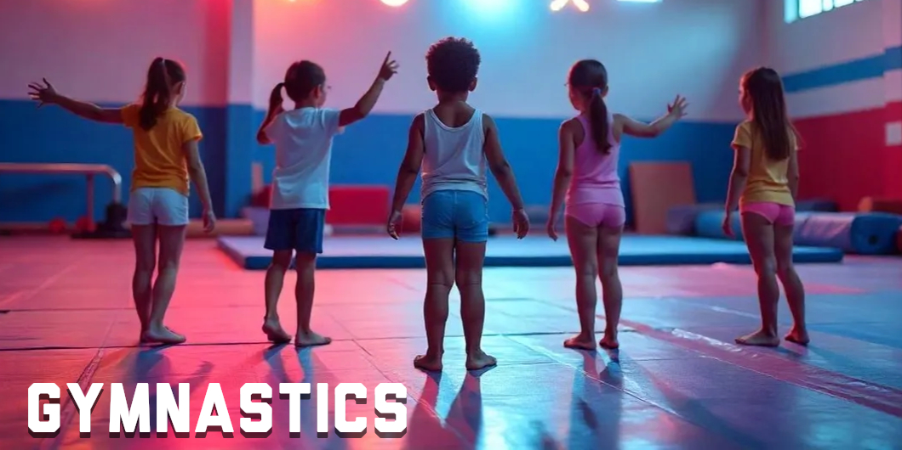
Why Knockout is The Best One in Gymnastics Training?

"Knockout Gymnastics: Flip, Fly, and Reach New Heights!"
Knockout is the best choice for gymnastics training, offering expert coaches and a well-rounded program designed to enhance strength, flexibility, and technique. With a focus on proper form and progression, Knockout helps athletes of all ages and skill levels master the fundamentals and advance to higher levels of gymnastics. The gym provides a supportive, motivating environment that encourages both personal growth and athletic excellence, making it the perfect place to thrive in the sport of gymnastics.

In Gymnastics Training at Knockout Gymnastics Academy, you’ll receive expert guidance in flexibility, strength, coordination, and balance through professionally designed routines. Our program includes floor exercises, tumbling, and apparatus work such as bars and beams, tailored to various age groups and skill levels. Whether you're training for fitness, fun, or competition, our gymnastics classes help enhance body control, posture, and confidence. With a focus on safety and progressive learning, Knockout provides a supportive environment where every gymnast can thrive and reach their full potential.

🏆 Achievements & Community Impact
- Athletes from Knock Out have achieved national and international recognition, becoming champions in their respective disciplines.
- The academy has received several awards, including being recognized as the best Gymnastics academy in North India. Knockout MMA Academy

📍 Locations- Knockout Gymnastics Academy
- Janakpuri (West Delhi)
- Lajpat Nagar (South Delhi)
- Laxmi Nagar (East Delhi)
- Nangloi (West Delhi)
- Najafgarh (West Delhi)
- Noida (NCR)
- Gurugram (NCR)

For more information or to enroll in a program, you can visit their official website: https://martial-art.in/gymnastics or contact them at +91 9999053185.

